# **Project 3-AUbatch-A Batch Scheduling System**

**Gaoxiang Li gzl0034**

1. Design:
2. three scheduling polices:design to use three policies to schedule the job queue here are the algorithm code.

SJF:

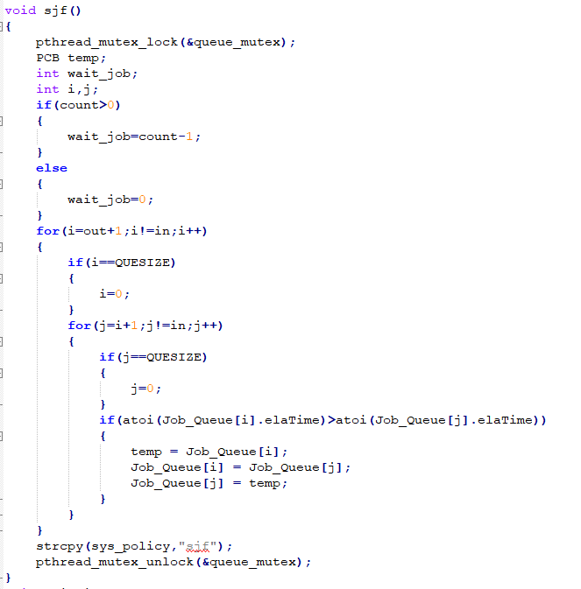

Fcfs:

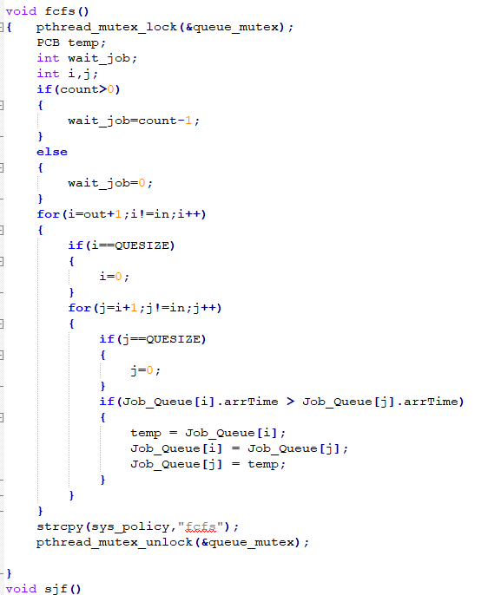

Priority:

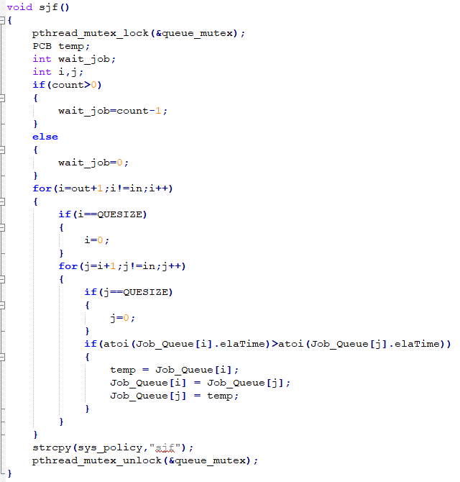

1. Command line parser:design to implement “help” “quit” “list” “run” “test” and switch policy function.(more details in source code)
2. Scheduler and Dispatcher: Scheduler get the submitted job and schedule the job, then put job into job queue. Dispatcher get and execv the job from job queue. Two processes use pthread to control synchronization between these two.(more details in source code)
3. Sample input and output:
4. priority policy

Input: test job priority 5 5 1 10

Benchmark:job policy:priority number of job:5 priority level:5

MIN_CPU TIME:1 MAX_CPU TIME 10

>list to show job queue

>quit to exit and show performance data

Here are the output screenshot:

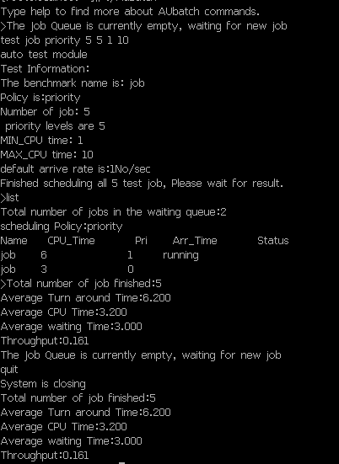

(2)FCFS

Input: test job fcfs 5 5 1 10

Benchmark:job policy:fcfs number of job:5 priority level:5

MIN_CPU TIME:1 MAX_CPU TIME 10

>list to show job queue

>quit to exit and show performance data

Here are the output screenshot:

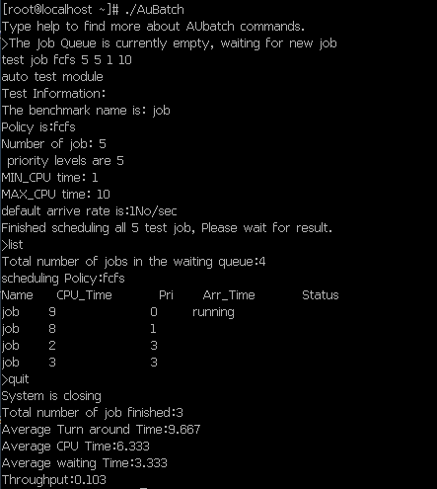

(3)SJF

Input: test job sjf 5 5 1 10

Benchmark:job policy:sjf number of job:5 priority level:5

MIN_CPU TIME:1 MAX_CPU TIME 10

>list to show job queue

>quit to exit and show performance data

Here are the output screenshot:

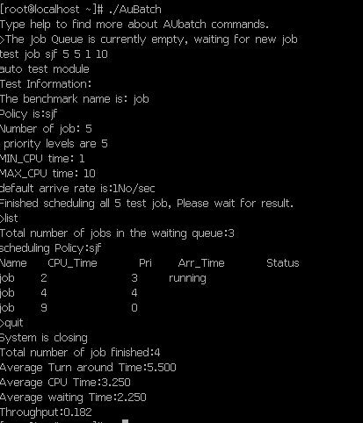

**Reference: Source code and slides provided by Dr.Qin**

**Scheduling policy algorithm from stack overflow (idea only)**